Nama : Luthvi Ramasandhika Yustiadi

NIM : 200411100132

Kelas : Proyek Sains Data 5E

Dataset

* Konteks

Semakin banyaknya obesitas pada manusia mengakibatkan pertumbuhan kurang sehat. Dataset berikut adalah Body Mass Index (BMI) yang saya ambil dari Kaggle.

* Informasi atribut
* Age : usia mempengaruhi pola hidup
* Height : tinggi badan
* Weight : berat badan
* Bmi : faktor ketentuan dengan rumus (height / weight^2)

Analisa fitur

* 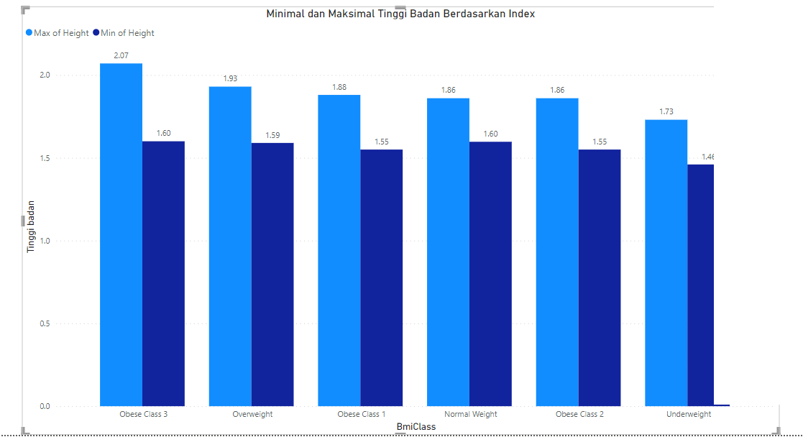Nilai minimal dan maksimal tinggi badan berdasarkan index
* Nilai maksimal dan minimal height dan bmiclass berdasarkan obese class 3

|  |  |
| --- | --- |
|  | Height (m) |
| Maksimum | 2.07 |
| Minimum | 1.60 |

* Nilai maksimal dan minimal height dan bmiclass berdasarkan overweight

|  |  |
| --- | --- |
|  | Height (m) |
| Maksimum | 1.93 |
| Minimum | 1.59 |

* Nilai maksimal dan minimal height dan bmiclass berdasarkan obese class 1

|  |  |
| --- | --- |
|  | Height (m) |
| Maksimum | 1.88 |
| Minimum | 1.55 |

* Nilai maksimal dan minimal height dan bmiclass berdasarkan normal weight

|  |  |
| --- | --- |
|  | Height (m) |
| Maksimum | 1.86 |
| Minimum | 1.60 |

* Nilai maksimal dan minimal height dan bmiclass berdasarkan obese class 2

|  |  |
| --- | --- |
|  | Height (m) |
| Maksimum | 1.86 |
| Minimum | 1.55 |

* Nilai maksimal dan minimal height dan bmiclass berdasarkan underweight

|  |  |
| --- | --- |
|  | Height (m) |
| Maksimum | 1.73 |
| Minimum | 1.46 |

* Nilai minimal dan maksimal berat badan berdasarkan index

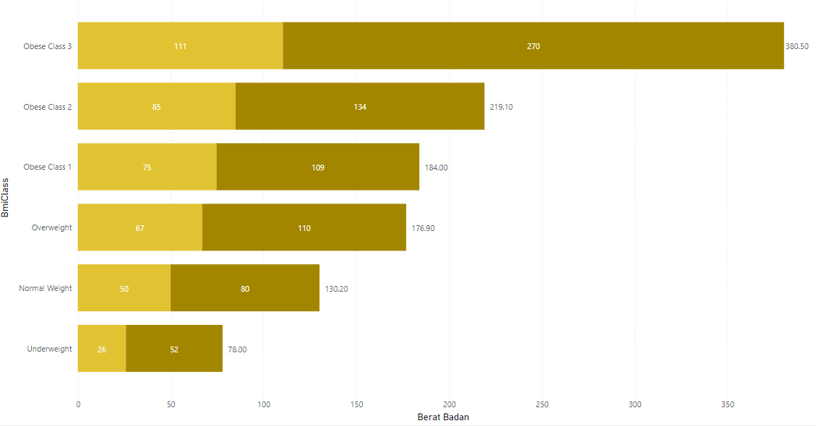

* Nilai maksimal dan minimal weight dan bmiclass berdasarkan obese class 3

|  |  |
| --- | --- |
|  | Weight (kg) |
| Maksimum | 270 |
| Minimum | 111 |

* Nilai maksimal dan minimal weight dan bmiclass berdasarkan obese class 2

|  |  |
| --- | --- |
|  | Weight (kg) |
| Maksimum | 134 |
| Minimum | 85 |

* Nilai maksimal dan minimal weight dan bmiclass berdasarkan obese class 1

|  |  |
| --- | --- |
|  | Weight (kg) |
| Maksimum | 109 |
| Minimum | 75 |

* Nilai maksimal dan minimal weight dan bmiclass berdasarkan overweight

|  |  |
| --- | --- |
|  | Weight (kg) |
| Maksimum | 110 |
| Minimum | 67 |

* Nilai maksimal dan minimal weight dan bmiclass berdasarkan normal weight

|  |  |
| --- | --- |
|  | Weight (kg) |
| Maksimum | 80 |
| Minimum | 50 |

* Nilai maksimal dan minimal weight dan bmiclass berdasarkan underweight

|  |  |
| --- | --- |
|  | Weight (kg) |
| Maksimum | 52 |
| Minimum | 26 |

* Rentang usia berdasarkan index

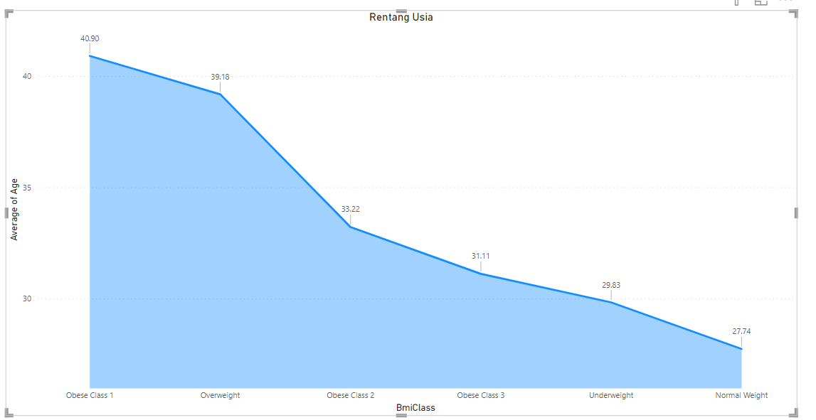

* Rata – rata usia berdasarkan index bmiclass

|  |  |
| --- | --- |
|  | Rata – rata usia |
| Obsese class 1 | 40.90 |
| Overweight | 39.18 |
| Obese class 2 | 33.22 |
| Obese class 3 | 31.11 |
| Underweight | 29.83 |
| Normal weight | 27.74 |

* Jumlah data berdasarkan index

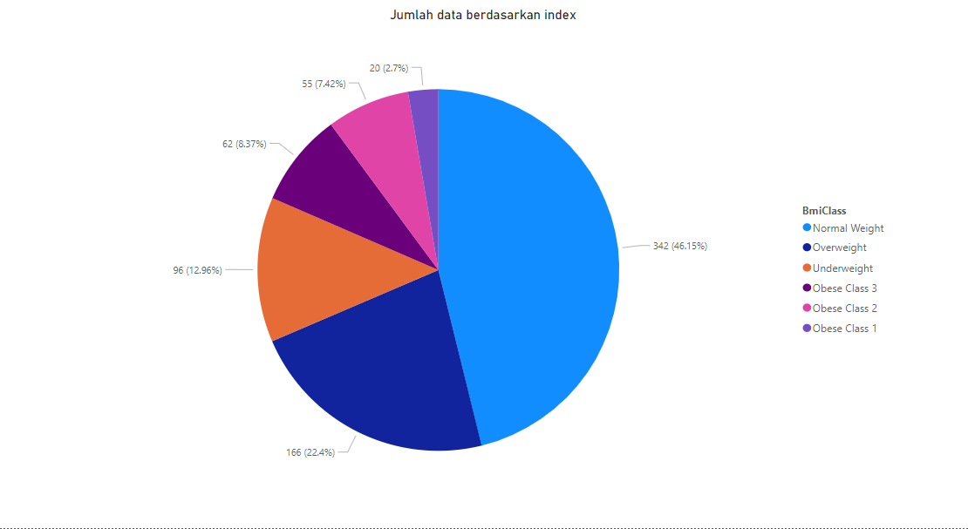

* Jumlah data bedasarkan index

|  |  |
| --- | --- |
|  | Jumlah |
| Underweight | 96 |
| Normal weight | 342 |
| Overweight | 166 |
| Obese class 1 | 20 |
| Obese class 2 | 55 |
| Obese class 3 | 62 |

Transform data

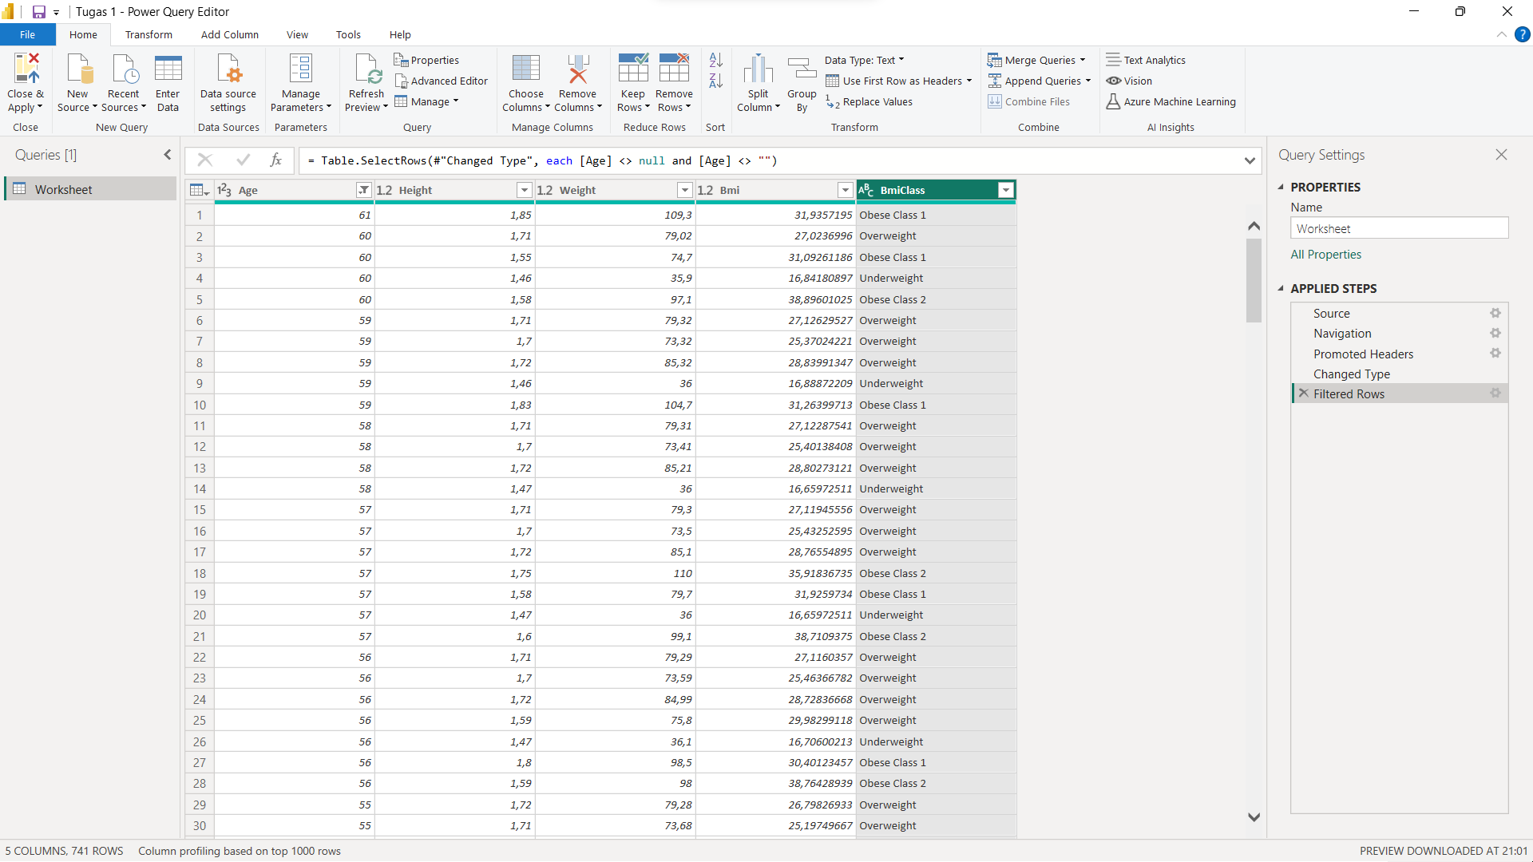

Tidak adanya transform data karena data sudah bersifat numerik semua.